✅

Objective Questions

Question 1

(1/1)

Which statement is true for the Normal distribution?
- (a) Always skewed right
- ✅ (b) Mean, median, and mode are equal (Correct)
- (c) Only applies to discrete variables
- (d) Defined only for x > 0

Question 2

(1/1)

Probability of exactly two heads in three fair coin flips:
- (a) 1/8
- ✅ (b) 3/8 (Correct)
- (c) 1/2
- (d) 2/3

Question 3

(1/1)

Model for occurrences in a fixed interval with rate λ:
- (a) Normal
- (b) Uniform
- ✅ (c) Poisson (Correct)
- (d) Exponential

Question 4

(1/1)
- (a) 1/4
- (b) 1/3
- ✅ (c) 1/2 (Correct)
- (d) 2/3

Question 5
- ✅ (a) aE[X] + b (Correct)
- (b) aE[X]
- (c) E[X] + b
- (d) a + bE[X]

Question 6

(1/1) 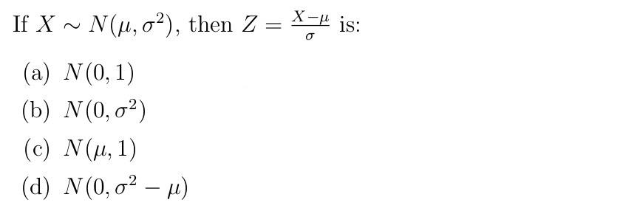
- (a)
- ✅ (b) (Correct)
- (c)
- (d)

❌

Incorrect Answers

Question 7

(0/1)
I have data where the maximum value is 100. Someone changed the data entry of 100 to 106. Which of the following is most likely to not get affected?
Outlier change from 100 → 106, what is least affected?
- (a) Mean
- (b) Median
- ✅ (c) Standard deviation (Correct Answer)
- ❌ (d) Range (Your Answer)

Question 8

(0/1) We take height data from students of class V and XII from a school. Assume, there are same number of students in both classes and the number of students is also large. The histogram of the combined height data will be

Combined height histogram (Class V & XII):
- (a) Uni-modal
- (b) Multi-modal
- (c) Approximately symmetric (Correct Answer)
- ❌ (d) Always right skewed (Your Answer)

Question 9

(0/1)
We collected data from 1000 people asking which brand’s soap they use. Among the options, which visualization tool is best to visualize market shares of the soap brands?Best visualization for market share:
- (a) Histogram
- (b) Boxplot
- (c) Bar chart (Your Answer)
- ✅ (d) Pie chart (Correct Answer)

Question 10

(0/1)
We have annual exam marks in Science and Mathematics of students in class X of a school. Assume all students appeared for both the subjects. We calculated the correlation coefficient and found it −0.5. What can be said by this observation?
Correlation = -0.5 implies:
- (a) Science causes lower Math
- (b) Math causes lower Science
- ✅ (c) Negative linear relationship exists (Correct Answer)
- ❌ (d) Both (a) and (b) (Your Answer)


